Subject: Project Update – Summary of Technical Efforts & Findings
Hello April,
Thank you for your email and for continuing the discussion on this project.
I would like to share a consolidated summary of the efforts and analysis our engineering team has undertaken so far, so that you can clearly see the depth of work that has been done to identify and resolve the technical issues. Also, please see the Video and the debugging log below this. You will be able to see the BlueTooth name the V1 is publishing.

1. Initial Situation
When we received the project code around two months ago, we did not have any physical hardware or reference documentation.
At that time:
- There was no clarity on which firmware version was uploaded to the PCB.
- The latest codebase was not confirmed.
- Hardware schematics and connectivity details were not fully available.
Despite these constraints, our team began detailed reverse engineering to understand and validate the firmware behavior.

2. Code Compilation and Preliminary Testing
- Compiled and analyzed multiple versions of the provided source code.
- Attempted to identify the version that might have been uploaded on the physical PCB.
- Created a Proof of Concept (POC) on a breadboard setup, simulating the Wax Heater hardware.
- Tested with two different firmware versions (V1) to replicate the issues mentioned in your earlier reports.
- Procured and integrated temperature sensors and relay modules to reproduce heater control behavior in a lab environment.

3. Analysis After Receiving the Physical Product
After receiving the actual product hardware from your side, we again replicated the setup to match the final product.
During this phase, we discovered several inconsistencies:
- The hardware design used a Relay, whereas the provided firmware was written for a MOSFET driver.
- The firmware (V1) was attempting to advertise Bluetooth, whereas based on our discussion and your product’s website demonstration, the device should have been Wi-Fi-based.
- This confirmed that the firmware available to us did not correspond to the latest production version (V1).
Additionally, the breadboard-based POC did not show any Wi-Fi advertisement — further proving that the available firmware was outdated.

4. Investigation on Version 2 (V2) Hardware
Once we received the V2 hardware and the latest firmware, we successfully compiled and ran the code.
However, through serial monitoring and detailed logging, we observed the following issues:
- The firmware was advertising a Bluetooth device name, but no Wi-Fi signal or access point was actually being broadcast.
- The thermostat sensor (DS18B20) returned temperature readings, but the system did not perform the corresponding logical actions (Relay ON/OFF).
- LED status indications for heating, standby, and connectivity were non-functional.
All these findings were verified on real hardware as well as through our breadboard-based replication, and we generated complete log files to document these behaviors.

5. Challenges & Observations
This project inherently involves multiple layers — firmware, electronics, sensors, and communication protocols — which require extensive back-and-forth testing to ensure robustness.
Because of the mismatches between the earlier firmware and the current hardware, significant effort was spent just in identifying and aligning the versions.
To make the platform more stable and scalable for production, we performed internal R&D and concluded that the existing module had limitations in Wi-Fi communication and firmware update handling.

6. Decision to Move Toward ESP32-C5
After analyzing all the above findings and discussions with your team, we decided to migrate to the ESP32-C5 module.
This decision was made only after validating the ground-level results, because:
- ESP32-C5 offers stable Wi-Fi connectivity, native OTA support, and better integration tools.
- It will allow us to create a robust, testable, and upgradable architecture for future versions of the product.
- The migration ensures that the system can be tested across multiple chips and conditions (over-heating, network interruptions, safety cut-offs, etc.), achieving industrial reliability.

7. Summary of Efforts So Far
Activity | Description
Code Analysis | Reviewed multiple firmware versions, cross-referenced logic with hardware behavior
Breadboard POC | Built full working setup to replicate temperature, relay, and LED control
Sensor & Relay Testing | Integrated DS18B20 + relay, validated threshold logic
Firmware Debugging | Identified mismatch in Bluetooth/Wi-Fi behavior
Hardware Validation | Tested V1 and V2 boards to verify boot logs and communication modules
Documentation | Generated serial logs, test videos, and configuration reports
Architecture Review | Evaluated migration to ESP32-C5 for long-term scalability

8. Moving Forward
We believe this project will require a phased and agile development plan, involving continuous testing across multiple hardware revisions and firmware iterations.
To ensure transparency, each phase will include:
- Defined deliverables
- Measurable testing checkpoints
- Client review and feedback loop
This approach will make the development process robust and reduce surprises at later stages.

Please review this summary and let us know if you’d like us to walk you through the test setup and logs in a short call.
We will then outline the next steps for the ESP32-C5-based development and testing cycle.
Warm regards,

Version 2 (Running) [04/Nov/2025)
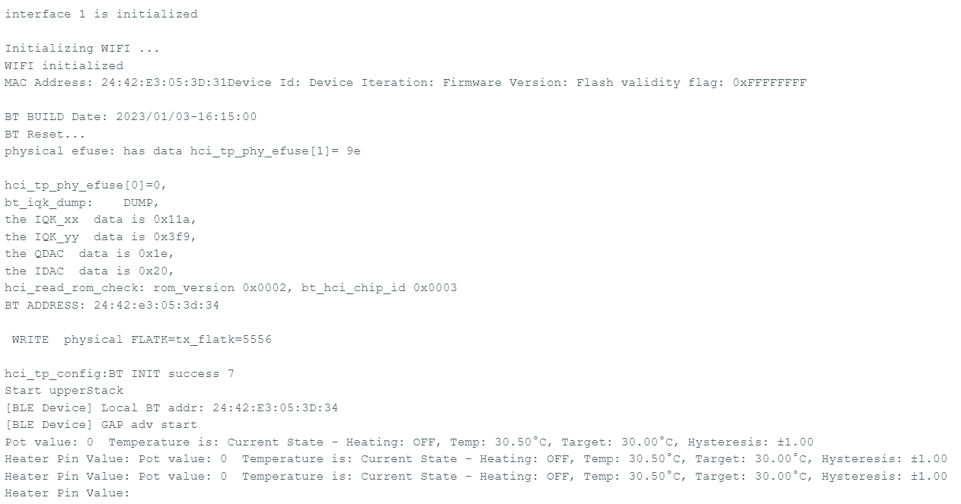

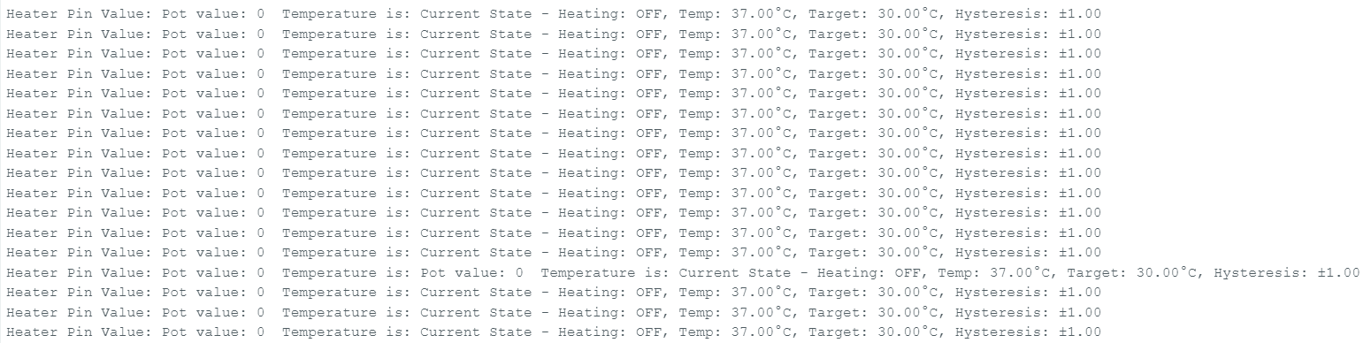
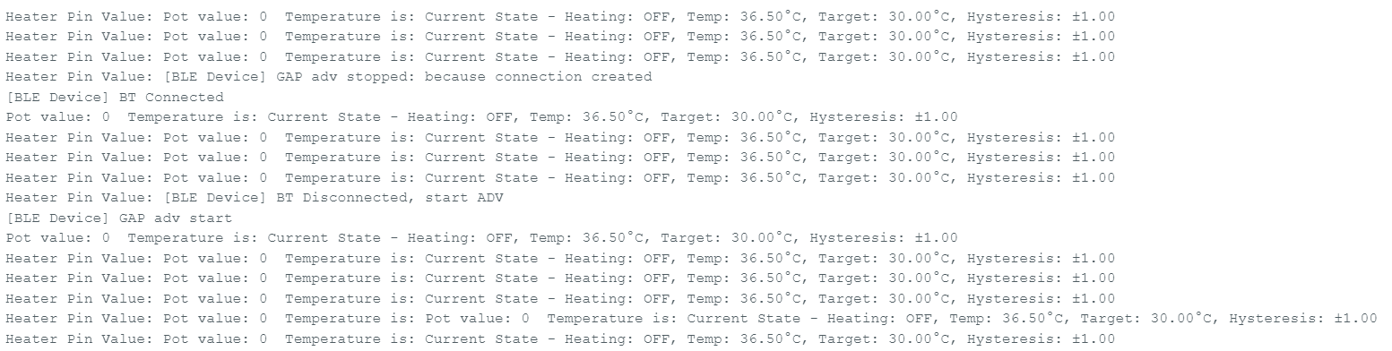
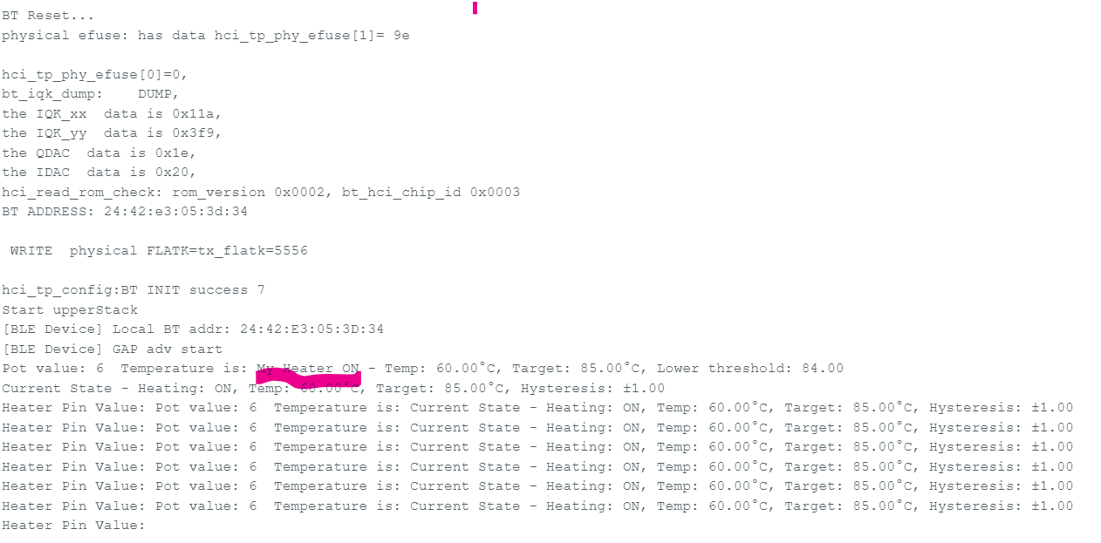
[This Board Design is for V1 on ESP8266]
